Database management project : Normalization
Name : Siddhika Santoshkumar Bejekar
MIS no : 111803136
Project : Agri-market(Agriculture management system)
AGRI-MARKET

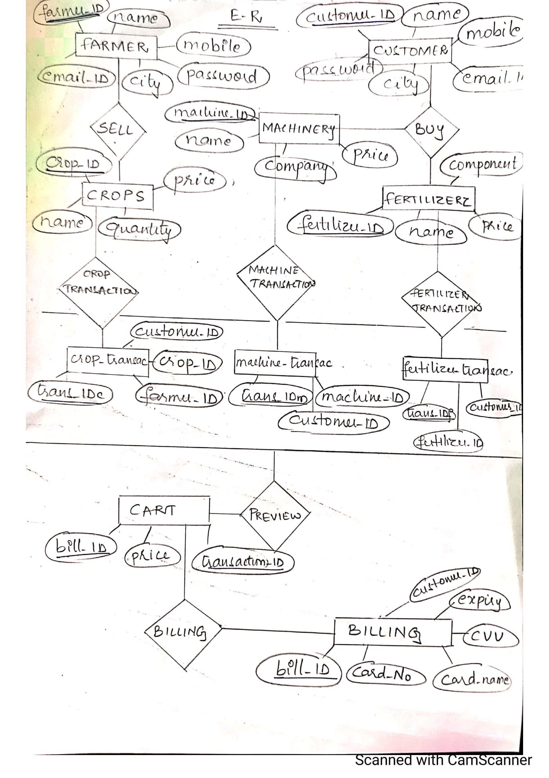

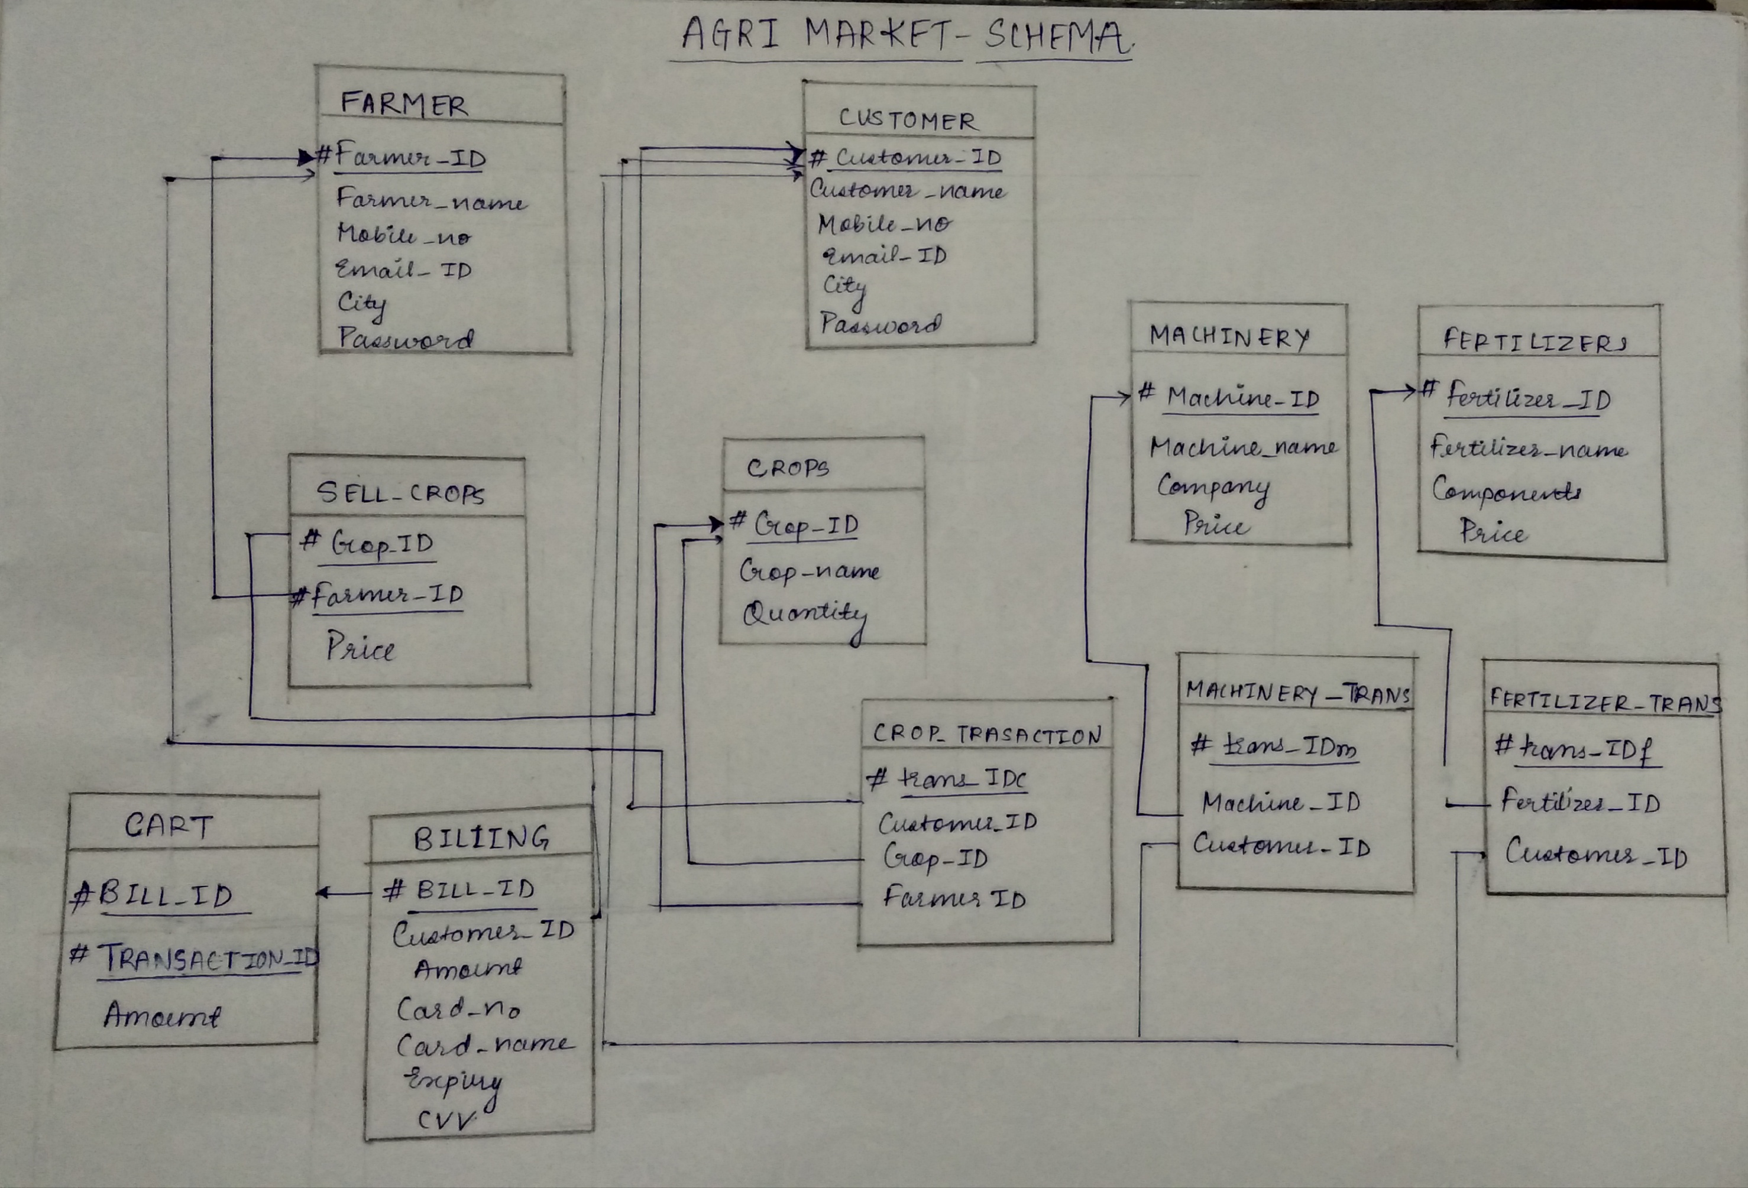

Normalization:
1)Farmer table:
#Farmer_id | Username | Name | Mobile_no | Email | Address | password
Primary key: Farmer_id
Functional dependencies:
{Farmer_id}-> Name, Mobile_no, Email, Address, Username
{username}-> password
Thus, by transitive property of Functional dependencies,
Farmer_id-> password
Closure of Farmer_id:
(Farmer_id)+ : {Name, Mobile_no, Email, Address, username, password}
Candidate key : Farmer_id
Prime attributes : Farmer_id
Non-prime attributes : Name, Mobile_no, Email, Address, username, password
There is no partial dependency, hence the table is in Second Normal form.
Username is non-prime attribute and username->password. Thus, not in Third Normal Form.

Farmer table :
#Farmer_id | Username | Name | Mobile_no | Email | Address
Functional dependencies:
{Farmer_id}-> Name, Mobile_no, Email, Address, username

Username table for farmer:
#username | password
Functional dependency:
{username}->password
Now the tables are in Third Normal Form.

2)Customer table:
#Customer_id | Name | Mobile_no | Email_id | Address | username | password

Primary key: Customer_id
Functional dependencies:
{Customer_id}-> Name, Mobile_no, Email, Address, username
{username}-> password
Thus, by transitive property of Functional dependencies,
Customer_id-> password
Closure of Customer_id:
(Customer_id)+ : {Name, Mobile_no, Email, Address, username, password}
Candidate key : Customer_id
Prime attributes : Customer_id
Non-prime attributes : Name, Mobile_no, Email, Address, username, password
There is no partial dependency, hence the table is in Second Normal form.
Username is non-prime attribute and username->password. Thus, not in Third Normal Form.

Customer table:
#Customer_id | username | Name | Mobile_no | Email | Address
Functional dependencies:
Customer_id->Name, Mobile_no, Email, Address, username

Username table for customer:
#Username | password
Functional dependency :
username->password

Now the tables are in Third Normal Form.

Table for Products that can be sold by farmers and can be bought by customers :
The crops are sold by farmers on the site.
3)Crops table:
#Crop_id | #Farmer_id | Crop_name | Farmer_name | price

Primary key: {Crop_id, Farmer_id }
Foreign key : Farmer_id
Functional dependencies:
{Crop_id, Farmer_id}-> Price
{Crop_id}-> Crop_name
{Farmer_id}-> Farmer_name
{Crop_id, Farmer_id}-> Farmer_name, Crop_name, price
Thus, Candidate key : {Crop_id, Farmer_id}
Prime attributes : Crop_id, Farmer_id
Non-prime attributes : Farmer_name, Crop_name, price
There is partial dependency as Farmer_name is partially dependent on only farmer_id of candidate key and Crop_name dependent only on Crop_id.

Crop by farmers:
#Crop_id | #Farmer_id | Price

Crops:
#Crop_id | Crop_name

Farmer selling crops:
#Farmer_id | Farmer_name

Now there is no partial dependency. The table is in Second Normal Form.
There are no Transitive functional dependencies. Thus, the tables are in Third Normal Form.

The fertilizers and machine can be bought by farmers directly from the site.
4)Fertilizers table:
#Fertilizer_id | Fertilizer | components | price

Primary key : Fertilizer_id
Functional dependencies:
{Fertilizer_id}->Fertilizer, components, price
There is no partial dependency, hence the table is in Second Normal form.
There are no transitive functional dependencies, thus it is in Third Normal Form.

5)Machine table:
#Machine_id | machine | Company | price

Primary key : Machine_id
Functional dependencies:
{Machine_id}->Machine, Company, Price
There is no partial dependency, hence the table is in Second Normal form.
There are no transitive functional dependencies, thus it is in Third Normal Form.

Transaction tables:
6)Transaction table for buying crops:
#Transaction_id | Customer_id | Customer_name | Crop_id | Crop_name | Farmer_id | Farmer_name
Primary key : Transaction_id
Foreign keys: Customer_id, Crop_id, Farmer_id
Functional dependencies:
Transaction_id-> Crop_id, Cust_id, Farmer_id
Crop_id->Crop_name
Farmer_id->Farmer_name
Customer_id-> Customer_name
Thus, by the property of transitive dependency,
Transaction_id->Customer_id, Customer_name, Crop_id, Crop_name, Farmer_id,Farmer_name
Transaction_id is the candidate key
Prime attributes : Transaction_id
Non prime_attributes : Customer_id, Customer_name, Crop_id, Crop_name, Farmer_id,Farmer_name

There is partial dependency, so to convert to 2NF,
#Transaction_id | Customer_id | Crop_id | Farmer_id
Primary key: Transaction_id
FD: Transaction_id -> Customer_id, Crop_id, Farmer_id
There is no transitive dependency within this table.

#Customer_id | Customer_name
Primary key : Customer_id
FD : Customer_id-> Customer_name

#Crop_id | Crop_name
Primary key : Crop_id
FD: Crop_id-> Crop_name

#Farmer_id | Farmer_name
Primary key : Farmer_id
FD: Farmer_id-> Farmer_name

Thus, all the tables are in 2NF there are no transitive dependencies within any table. Thus, they are in Third normal form(3NF).

7)Transaction table for buying fertilizers:
#Fertilizer_trans_id | Fertilizer_id | Farmer_id
Primary key : Fertilizer_trans_id
Foreign keys: Farmer_id, Fertilizer_id
Functional dependencies:
Fertilizer_trans_id -> Fertilizer_id, Farmer_id

8)Transaction table for buying machinery:
#Machine_trans_id | Machine_id | Farmer_id
Primary key : Machine_trans_id
Foreign keys: Farmer_id, Machine_id
Functional dependencies:
Machine_trans_id -> Machine_id, Farmer_id

